GENERAL CONFEDERATION OF LABOR OF VIETNAM

**TON DUC THANG UNIVERSITY**

**FACULTY OF INFORMATION TECHNOLOGY**



**Enterprise Systems Development Concepts**

*Instructing Lecturer*: **MR. DUONG HUU PHUC**

*Student’s name*: **Nguyen Gia Khiem – 520H0464**

**Nguyen Tran Thanh Duy – 520H0624**

**Nguyen Hai Duy – 520H0623**

Class**: 20H50303**

Course**: 24**

**HO CHI MINH CITY, 2023**

GENERAL CONFEDERATION OF LABOR OF VIETNAM

**TON DUC THANG UNIVERSITY**

**FACULTY OF INFORMATION TECHNOLOGY**



**Enterprise Systems Development Concepts**

*Instructing Lecturer*: **Mr. DUONG HUU PHUC**

*Student’s name*: **Nguyen Gia Khiem – 520H0464**

**Nguyen Tran Thanh Duy – 520H0624**

**Nguyen Hai Duy – 520H0623**

Class**: 20H50303**

Course**: 24**

**HO CHI MINH CITY, 2023**

ACKNOWLEDGEMENT

I would like to express my sincere and deep gratitude to **Mr. Duong Huu Phuc** for guiding and helping us enthusiastically in the process of completing the report. After studying the *ESDC* course, we have learned a lot about developing and using Java which can help us improve my knowledge and coding methods.

In the process of making this essay, mistakes will inevitably be made, we would like to receive your comments and suggestions so that we can further broaden our understanding on the subject and improved for the following exercises.

Thank you sincerely!

*Ho Chi Minh City, March 22nd, 2023*

*Author*

*(sign and write full name)*

*Khiêm*

*Nguyen Gia Khiem*

*Duy*

*Nguyen Tran Thanh Duy*

*Duy*

*Nguyen Hai Duy*

THE REPORT WAS COMPLETED  
 AT TON DUC THANG UNIVERSITY

We pledge that this is a product of our report and is under the guidance of **Mr. Duong Huu Phuc**. The content of research results in this subject are honest and have not been published in any form before. The data in the tables used for the analysis, comment, and evaluation were collected by the authors themselves from various sources indicated in the reference section.

In addition, many comments and assessments as well as data from other authors and organizations have been used in the report, with references and annotations.

**If any fraud is found, we are fully responsible for the content of our report.** Ton Duc Thang University is not involved in any copyright infringement or copyright infringement in the course of implementation (if any).

*Ho Chi Minh City, March 22nd, 2023*

*Author*

*(sign and write full name)*

*Khiêm*

*Nguyen Gia Khiem*

*Duy*

*Nguyen Tran Thanh Duy*

*Duy*

*Nguyen Hai Duy*

EVALUATION FROM INSTRUCTING LECTURER

**Confirmation from the instructor**

_______________________________________________________________________________________________________________________________________________________________________________________________________________________________________________________________________________________________________________________________________________________________________________________________________________

*Ho Chi Minh City, 2023*

*(sign and write full name)*

**The assessment of the evaluation teacher**

_______________________________________________________________________________________________________________________________________________________________________________________________________________________________________________________________________________________________________________________________________________________________________________________________________________

*Ho Chi Minh City, 2023*

SUMMARY

The report contains:

1. System Overview
2. System analysis and design
3. Realize system
4. Demo

The software will have functions:

TABLE OF CONTENT

ACKNOWLEDGEMENT i

EVALUATION OF INSTRUCTING LECTURER iii

SUMMARY iv

TABLE OF CONTENT 1

LIST OF DIAGRAMS, CHARTS AND TABLES 3

LIST OF SYMBOLS AND ABBREVIATIONS 4

CHAPTER 1 – SYSTEM OVERVIEW 5

1.1 Introdction 5

1.2 System specification 5

1.3 Topic scope 7

1.3.1 Limits on objects and functions 35

1.3.2 Limits on tchnology 35

1.4 Practical implications 8

1.5 Report layout 8

CHAPTER 2 – SYSTEM ANALYST AND DESIGN 9

2.1 Function requirements 9

2.2 Non-function requirements 13

2.3 Funtional diagram 15

2.3.1 Use-case diagram 35

2.3.2 Use-case specification 35

CHAPTER 3 – SYSTEM IMPLEMENTATION 34

REFERENCES 91

LIST OF DIAGRAMS, CHARTS AND TABLES

LIST OF SYMBOLS AND ABBREVIATIONS

1. – SYSTEM OVERVIEW
   1. Introduction:

This report illustrates the basic operation of A Booking Movie Ticket System. This system contains some fundamental functions for customers, managers and employees of a cinema.

A system is just a minor and elementary project as a demo for booking movie ticket which is relevant to ordering and selling services. We have analyzed and determined to develop a system as our module and a project is entitled DDK-cinema contemporarily.

* 1. System specification:

The Booking Movie Ticket System supports users for online or offline booking. They can purchase an online ticket if they do not want to queue for movie tickets or they can go directly the front desk and buy movie tickets.

Customer can interact with a booking website easily, when customers want to purchase movie tickets, they can use Create Booking Function to initial a booking form and then the system will require them to log in. If guests have not had any account, they can press the registration button to sign up. Customers can use their telephone number to register and the system will provide an account with their ID, account name, password. In booking stage, customers have to select a movie which they want to watch, they must assign some compulsory functions for a booking process include choosing a theater, appointing a movie show and selecting available chairs. When they have done these functions, they can make payment by card, cash or electronic wallet. When these stages complete, customers will verify all the details of their booking. After all, the system will give them the online tickets and customers can view details contain….

The system also provides all the booking functions for front desk officers who will sell movie tickets to customers directly. They must log in and choose a theater where they work on. Their booking functions is similar with customers’ booking functions so it easily for staffs and customers using but when creating booking, they don’t have to choose a theater and they will support customers re-checking, make payment and print tickets in order to give customers.

In manage side,

* 1. Topic scope:
     1. Limits on objects and functions:

Objects:

* All customers.
* All members of a cinema.

Functions:

* Buy movie tickets.
* Make Payment
* Receive tickets
* Cancel Booking
* Add Movie
* Modify Movie
* View Sold Ticket
* Add Show
* Modify Show
* Cancel Show
* Create Employee Account
  + 1. Limits on technology:
* Front-end: HTML, CSS, JS.
* Back-end: PHP.
* Database: My SQL.
  1. Practical implications:
* Supply an online website for guests to seek out and purchase a movie ticket.
* Assist a cinema to sell online and offline tickets for customers.
  1. Report layout:
* Chapter 1: System overview.
* Chapter 2: System analysis and Design.
* Chapter 3: System implementation.
* Chapter 4: References.

1. – SYSTEM ANALYST AND DESIGN
   1. Function requirements:

General functions:

* Login
* Logout
* Change Password Account

Booking functions:

* Register Account
* Create Booking
* Select Movie
* Choose Theaters
* Choose Movie Show
* Assign Seats
* Make Payment
* Verify Payment
* Receive tickets
* Cancel Booking
* Add Coupon

Manage functions:

* Add Movie
* Modify Movie
* View Sold Ticket
* Add Show
* Modify Show
* Cancel Show
* Create Employee Account
* Modify Status of Employee Account

* 1. Non - function requirements:
* System is reliable for users.
* System has a quick response time
* System has the ability for expansion.
* System has pleasant and responsive interactions between system, customers and a company.
* Web page has a simple and friendly display for looking and selecting products.
  1. Functional diagram
     1. Use-case diagram:

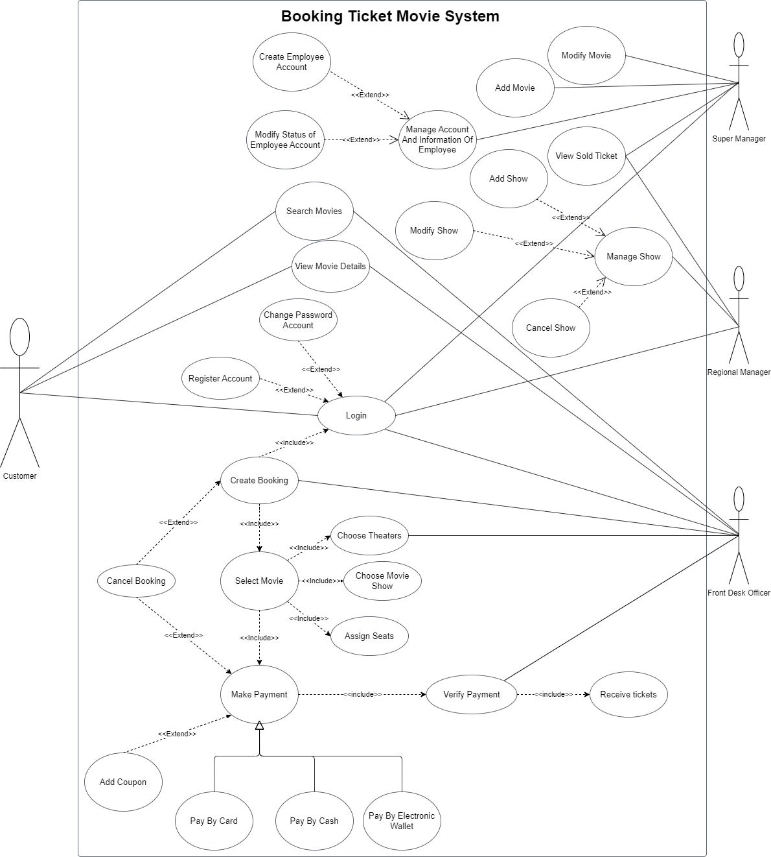

Figure 2.1: Use-case diagram for Booking Movie Ticket System.

* + 1. Use-case specification:

List of actors in the system:

|  |  |
| --- | --- |
| Actor | Description |
| Customer | - Customers can search movies and view movie details on the website to select their desired movies.  - Customers figure out an interesting movie, they can create a booking in order to purchase an online ticket. A system is going to require them to login their account for payment. If customers don’t have an account, they must register an account to make payment.  - Customers have to choose a theater and a movie show, then they assign available seats. After all, they can make payment by card, cash or electronic wallet and verify their bill. In final stage, they will receive their online tickets.  - In option, Customers can add their coupon to get a great discount, they have the authorization for canceling booking and customers can modify their password account. |
| Super Manager | - A super manager has the highest power in the system, who administers all the information of employees. A super manager can create and provide accounts for employees and control the status of an account.  - A super manager administers all movies in a cinema, who can add movies and modify their details.  - Super manager view and manage sold tickets. |
| Regional Manage | - A regional manager administers all the shows of a cinema. Who determines to add, alter and cancel movie shows.  - A regional manager can view and check sold tickets in cinemas are under his/her control. |
| Front Desk Officer | - Front desk officers will interact with customers directly. They must login with a supplied account and select a theater.  - Front desk officers support customers by creating tickets for them. They can search according to customers’ requests, initiate booking and assist customers to choose a show and seats. When making payment, they will verify for customers, ask customers for adding coupons or help customers to cancel their booking.  - Front desk officers give tickets to customers after complete payment. |

Table 2.1: List of actors in the system.

List of use-cases in the system:

|  |  |  |  |
| --- | --- | --- | --- |
| ID | Use-case name | Description | Actor |
| UC01 | Login | Login function allows all system users log in a system by their accounts. | Customer, Super Manager, Regional Manage, Front Desk Officer. |
| UC02 | Register Account | This function is used for customers who don’t have an account can join and create their accounts for serving booking movie ticket. | Customer. |
| UC03 | Change Password Account | Actor is allowed to alter their password account when they have a need. | Customer, Super Manager, Regional Manager, Front Desk Officer. |
| UC04 | Search Movies | It is an essential function which allows actor can find showing or coming movies. | Customer, Front Desk Officer. |
| UC05 | View Movie Details | Actor can view the detailed information of a movie such as running time, genre, director, rated, cast,… | Customer, Front Desk Officer. |
| UC06 | Create Booking | This function is the crucial feature of the system. Actor will create booking for gaining a movie ticket. | Customer, Front Desk Officer. |
| UC07 | Select Movie | Actor chooses a showing movie for purchasing a movie ticket. | Customer, Front Desk Officer. |
| UC08 | Choose Theaters | Actor can choose a near or a wanted theater. | Customer, Front Desk Officer. |
| UC09 | Choose Movie Show | Actor can select a show which is suitable for customers. | Customer, Front Desk Officer. |
| UC10 | Assign Seats | Actor can select seats and they have to assign available chairs. | Customer, Front Desk Officer. |
| UC11 | Make Payment | Actor will make a payment after they complete their booking stage. | Customer, Front Desk Officer. |
| UC12 | Verify Payment | This function is used for re-checking the details of their booking to guarantee there is no any mistake. | Customer, Front Desk Officer. |
| UC13 | Receives Tickets | After actor completes a payment, he/she will be given online tickets. | Customer. |
| UC14 | Add Coupon | This is an optional function. Actor can add their coupons to get a discount. | Customer. |
| UC15 | Cancel Booking | Actor can call off their booking when there is any mistake. | Customer, Front Desk Officer. |
| UC16 | Add Movie | Actor can manage and add a new movie in a cinema system. | Super Manager. |
| UC17 | Modify Movie | Actor can alter all the attributes of a movie in a cinema system. | Super Manager. |
| UC18 | Add Show | Actor can create and add the shows of a movie | Regional Manager. |
| UC19 | Modify Show | Actor can alter and move a show in an another time. | Regional Manager. |
| UC20 | Cancel Show | Actor can remove an available show. | Regional Manager. |
| UC21 | View Sold Ticket | Actor can view how many tickets they have sold and selling history | Super Manager, Regional Manager. |

Table 2.2: List of use-cases in the system.

1. – SYSTEM IMPLEMENTATION

In this section, we will show and explain our selected project technologies: PHP, HTML, CSS, Javascript, MySQL, Bootstrap framework.

Back-end: PHP is a server-side language which is an open source, have an extensive library and it is adaptable with multiple platforms and technologies. Besides that, PHP has a large community for supporting, especially, lightning speed and scalable ability which features will assist my system efficiently.

Front-end: HTML, CSS and Javascript is the fundamental of front-end technique, HTML creates web pages and CSS allows to make web pages great looking. In addition, Bootstrap framework is a serviceable framework which supports to decorate and arrange all items and elements, display a stunning view to users

Database: Using PHP because it supports PHP fully. Its advantages are free and open source. My SQL is fast, reliable, scalable, easy to use and cross-platform.

**Questionnaires:**

1. How often do you go to a cinema?

(a) Once a week

(b) About 2- 3 times in a month

(c) 2 months once

(d) Seldom

(e) Never

2. How do you often booking ticket using current movie booking system?

(a) Online

(b) Telephone

(c) SMS

(d) Never

(e) Other

3. What are the problems you face when buying tickets?

(a) Staff’s attitude

(b) Bad seats

(c) Long queue

(d) Inflexibility of booking (e.g.: phone line busy, website down etc) (e) Other

4. What movie company you usually visit?

(a) CGV

(b) BHD

(c) Galaxy Cinema

(d) Other

5. What are your expectations for an online tickets booking and touch screen kiosk system?

(a) Review bookings

(b) Choose seats

(c) User friendly system

6. Would you prefer a tickets booking system that allows you to choose the seats when booking or purchasing the movie tickets?

(a) Yes

(b) No

7. What age category do you fall in?

(a) 12- 16 (Junior)

(b) 17- 21 (Teens)

(c) 22- 49 (Adults)

(d) 50 and above (Senior)

8. Would you prefer more payment methods ?

(a) Yes

(b) No

9. Would you prefer to wait until the last Monday of the month to enjoy your movie or you just going to watch it at the time it is released?

(a) Wait for the promotion

(b) Enjoy it anyway

(c) Prefer to watch in free time

(d) Do not enjoy watching movie at the theater

10. Do you like to buy popcorn or snack just right after purchasing ticket?

(a) Yes

(b) No

(c) Depends on the movie (e.g.: film length, type of film,…..

InterviewtypeQuestions:

1. In your opinion, what makes an user-friendly and convenient ticketing system? Easy navigation

2. Do you know any of ticketing system online? ticketbox,...

3. What are the advantages of booking tickets on system to offline ticket purchasing?

• No need to queue

• Easy to pay through online payments

• Easy to find new events

4. What make you want to stay and using a ticketing system in the next times?

• Responsive

• Payments

• Prices

• Discounts

• Services

5. How important would you say customer service is? It is one of the main factors that keep customers staying with the ticketing system

6. Would you rather pay for the ticket by online payment or offline payment? Online payment, it will save a lot of time and more convenient for me.

7. Do you want the system to build up an advanced searching tool? Yes, because I do not want to spend so much time finding the exact event I want to join in.

8. What main color do you want to display on the website? I think simple color with Dark/Light mode activated